Listings Release
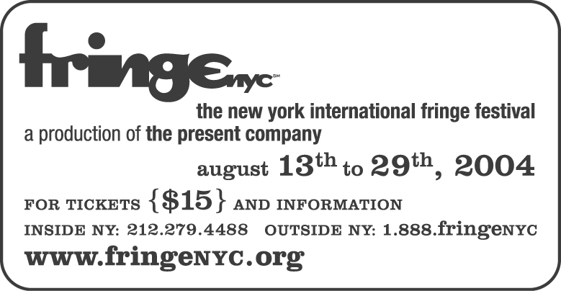
FR: Dennis Crowley
(212) 967-9939

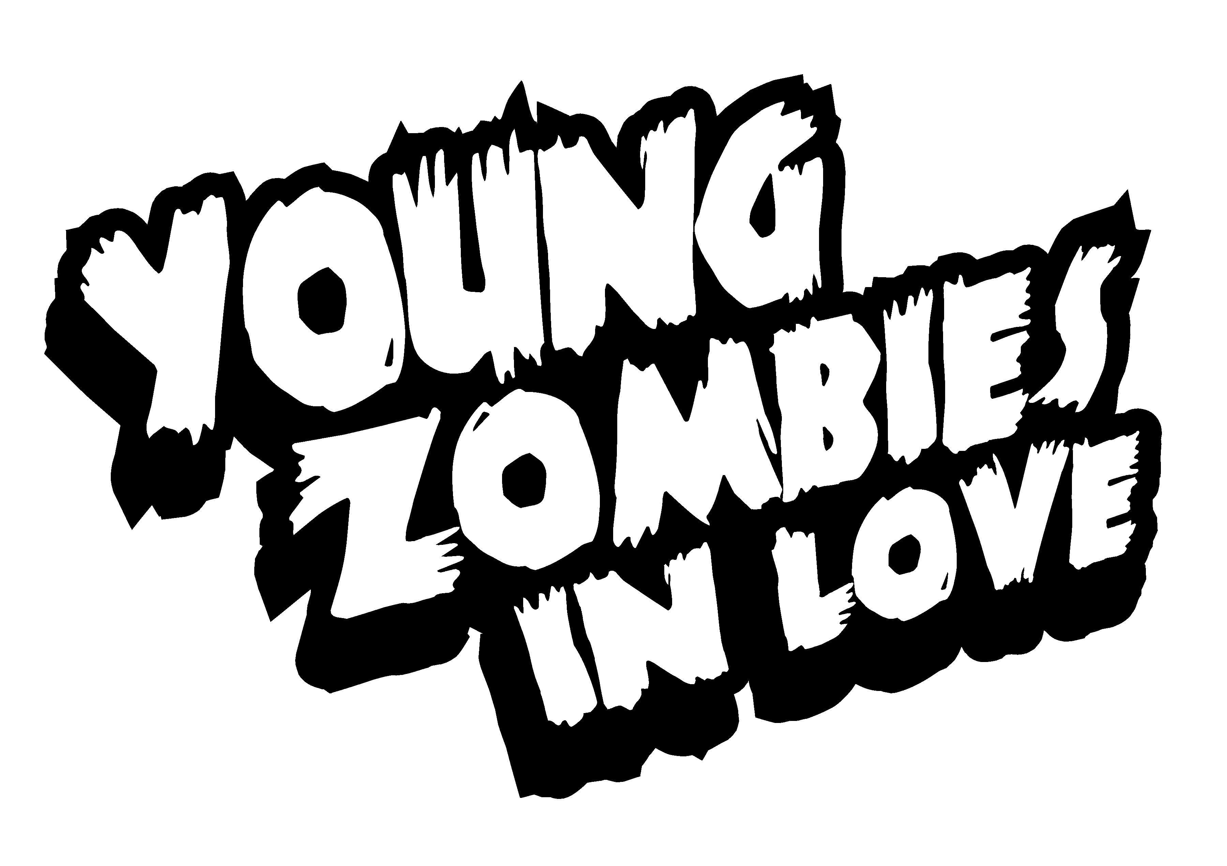

Title: Young Zombies in Love

Theatre: The Players Theatre (115 Macdougal St between 3rd & Bleecker)

Tickets: fringenyc.org
(212) 279-4488
(outside NY: 1-888-FringeNYC).

Dates: 5 performances August 14-28:

Saturday 14th Noon
Monday 16th 8 pm
Saturday 21st 8:30 pm
Friday 27th 3 pm
Saturday 28th 11 pm

Description: A new musical in the tradition of Rocky Horror Show and Little Shop of Horrors, Young Zombies in Love tells the story of two teens from Tombtown, USA and the tragic yet wacky turn their love affair takes after one of them is hacked up by an undead cheerleader. Can the young lovers fend off an onslaught of their zombified peers to stand together against apathy and brain-munching?

Credits: By Damian Hess with songs by Gaby Alter
Directed by Jackson Gay

Editors and writers:
For production art, please visit emeraldrain.com
dennis•Crowley 500 W 43rd St 11G NYC/10036 dc4a@earthlink.net

